01/05/2026
NAME: SAKINA MOHD | Age: AD | Sex: F
Clinical Details: OBS
OBSTETRICS ULTRASOUND REPORT
Maternal Survey:
Internal Os is closed.
Adnexa appear unremarkable.
Foetal Survey: -
- Sonogram revealed SINGLE intrauterine foetus.
- Presentation : Cephalic, Lying LONGITUDINAL
- Placenta Location : POSTERIOR
- Amniotic fluid : ADEQUATE
- Cardiac activity : PRESENT AND REGULAR

Biometry:
- Gestation age based on BPD, HC and FL is approximately (GA): 37weeks 01 day(s)
- Expected date of delivery by USG DD) : 22/05/2026
- Foetal weight : 2.75 Kg
- SEX:
IMPRESSION: Single live intrauterine fetus at 26 Weeks 02 day(s).

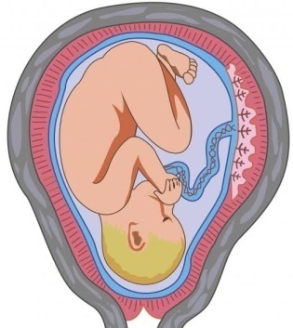

SONOGAPHER

